**パンゲア・プロクシマ  
Pangea Proxima**

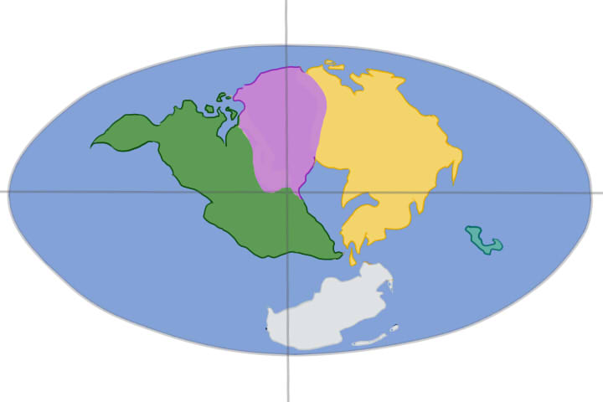

In a near future, a huge war accident has occurred called “ULTIMA” (ウルティマ), changing all the earth’s structure and affecting completely people’s lifestyle so far.

Mankind then has entered in a frenetic search for new technologies looking for suiting themselves to the new world. However, the lack of new resources and energy has led some years later most part of these attempts of world’s reconstruction among technology in mere ruins and deserts.

In this new world, now called “Pangea Proxima”, mankind not only pays the price for the war, but also due the unrestricted reconstruction at the post-war. The world outside is in chaos, extremely dangerous due many new creatures around, created before in the attempt of repopulating wildlife animals, which now they gather the few natural resources available.

20 years later, from the few survivors left, many tiny villages has appeared around the world, living with the least technology that has last and the incessant search for energy supplies which ended up being lost around by the years long.

Each one of these villages has a search group with young people with the task of seeking energy supplies, along with other workers at the village who helps with community works. Even though life is difficult in this new world, people are now already used with the lifestyle.

Until the moment that outside countries began threaten other villages, stealing their supplies as taxes and claiming an energy monopoly.

Tired of those injustices, each main character decides to go out from the village and defeat those responsible for the energy monopoly, as well searching for an extremely powerful energy source that some tales says that existed and was lost before the huge “ULTIMA” accident.

**パンゲア・プロクシマ**



Num futuro próximo, um grande acidente de guerra chamado de “ULTIMA (ウルティマ)” causou uma enorme modificação da estrutura terrestre, invertendo completamente os padrões de vida que os seres humanos tinham até então.

A humanidade entrou numa disputa frenética por novas tecnologias com intuito de adaptar-se ao novo mundo, porém a escassez de novos recursos e energia acabou em alguns anos mais tarde tornando grande parte das tentativas de construir um mundo novo em volta da tecnologia em meros desertos e ruínas.

Neste novo mundo, agora chamado de “Pangea Proxima”, a humanidade não só ainda paga pelo grande acidente, mas também pela consequência da descontrolada reconstrução do pós-guerra. O mundo afora não apenas caótico como também extremamente perigoso devido a diversas novas criaturas à solta, desenvolvidas com o intuito de repopular à vida animal extinta, e que hoje tomam conta dos poucos recursos naturais restantes.

20 anos mais tarde, dos poucos sobreviventes que sobraram, surgiram diversos pequenos vilas ao redor do mundo que vivem às custas da pouca tecnologia que restou e a busca constante por reservas de energias que acabaram se perdendo ao longo dos anos.

Cada um desses vilarejos possui uma equipe de jovens que são responsáveis por esta busca de recursos, e dividem os trabalhos da comunidade entre seus cidadãos. Embora a vida fosse difícil neste novo mundo, as pessoas já estavam acostumadas às novas rotinas.

Até o momento em que estas vilas começaram a ser ameaçadas por outros povos, roubando as reservas das vilas como impostos e clamando um monopólio dos recursos naturais.

Cansados das injustiças, o protagonista decide sair da vila para terminar de vez com os responsáveis pelo monopólio, e procurar uma fonte de recursos extremamente poderosa que segundo lendas, dizem ter se perdido antes do grande acidente do “ULTIMA”.

**Enneagram of Personality**

|  |  |  |  |  |  |  |  |  |
| --- | --- | --- | --- | --- | --- | --- | --- | --- |
|  | **Characteristic Role** | **Ego fixation** | **Holy idea** | **Basic fear** | **Basic desire** | **Temptation** | **Vice/**  **Passion** | **Virtue** |
| **1** | Reformer | Resentment | Perfection | Corruptness, imbalance, being bad | Goodness, integrity, balance | Hypocrisy, hypercriticism | Anger | Serenity |
| **2** | Helper | Flattery (Ingratiation) | Freedom, Will | Being unloved | To feel love | Deny own needs, manipulation | Pride | Humility |
| **3** | Achiever | Vanity | Hope, Law | Worthlessness | To feel valuable | Pushing self to always be "the best" | Deceit | Truthfulness, Authenticity |
| **4** | Individualist | Melancholy (Fantasizing) | Origin | Having no identity or significance | To be uniquely themselves | To overuse imagination in search of self | Envy | Equanimity (Emotional Balance) |
| **5** | Investigator | Stinginess (Retention) | Omniscience, Transparency | Helplessness, Incapable, Incompetent | Mastery | Replacing direct experience with concepts | Avarice | Non-Attachment |
| **6** | Loyalist | Cowardice (Worrying) | Faith | Being without support or guidance | To have support and guidance | Indecision, doubt, seeking reassurance | Fear | Courage |
| **7** | Enthusiast | Planning (Anticipation) | Wisdom, Plan | Being trapped in pain and deprivation | To be satisfied and content | Thinking fulfillment is somewhere else | Gluttony | Sobriety |
| **8** | Challenger | Vengeance (Objectification) | Truth | Being harmed, controlled, violated | Self-protection | Thinking they are completely self-sufficient | Lust (Forcefulness) | Innocence |
| **9** | Peacemaker | Indolence (Daydreaming) | Love | Loss, fragmentation, separation | Wholeness, peace of mind | Avoiding conflicts, avoiding self-assertion | Sloth (Disengagement) | Action |

http://en.wikipedia.org/wiki/Enneagram_of_Personality